Sample chapter layout page:

Email Reputation Management
At a Glance
No table of contents entries found.

Sample best practice:

Best Practice: This is why my best practice is to always schedule a Campaign Run in the future, even if it is 10 minutes from now.

Sample caution
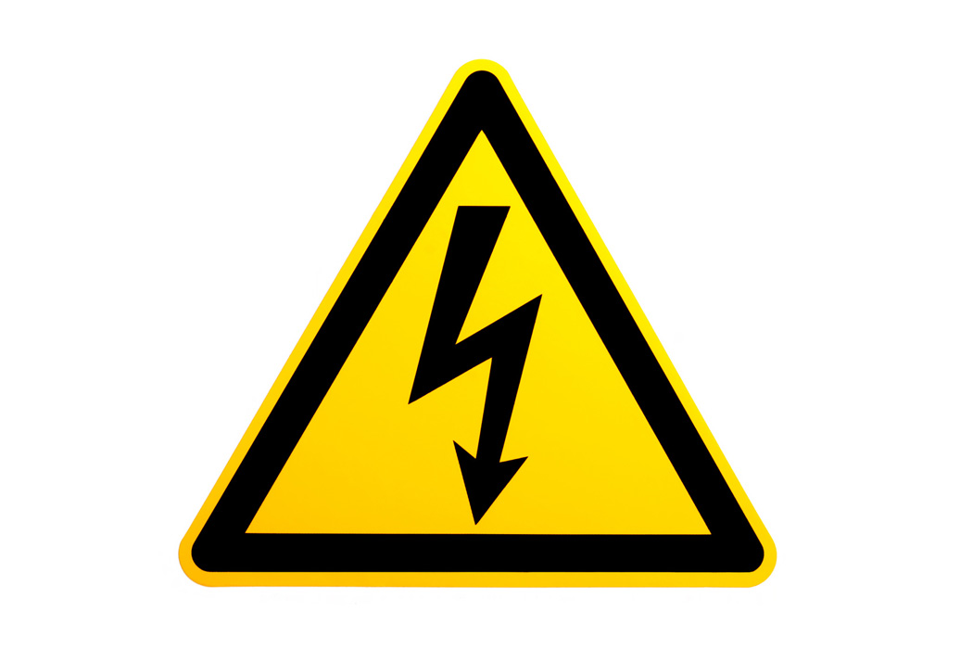 | Caution: This is a sample caution. You might want to revise that heading.

Sample note:
Note: for the Batch campaign, you will simply select Run Once then Run Now

Sample warning:
Warning: This is a sample warning.

Sample checklist:
Email Reputation Checklist
- SPF and DKIM are setup at the integration stage. [link back to that section]
- From address is from a valid domain from Step 1. Make sure this is an alias or box you have proxy control over. [Email Basics LINK]
- Use Marketo’s Email Checklist while building your templates.
- When building email templates, use a spam and viewing checker to verify your code is up to snuff: EmailOnAcid, Litmus.com, Mailchimp (paid), ReturnPath, or IBM Deliverability package.
- Avoid common spam words and sales-y content. Here are two recommended lists.
  - Sendblaster’s List:
  - Mannix Marketing:
- Subject line avoids non-alpha characters, ALL CAPS
- No rich media or scripting
- Limited images. Be sure to include ALT and Description tags to ensure people who block images in their email viewer can read what you intended.
- No hidden font colors such as White, Red, or Gray.
- Avoid too many font size changes or large fonts.
- Manage your database to clean out hard bounces, multiple bounces, and spam traps regularly.

Sample self-quiz:
Self-Quiz
What email keywords result in most clicks?

What is the difference between a soft bounce and a hard bounce?

What are email deliverability benchmarks?

Does Marketo have a tool for generating Email deliverability reports?

Sample formatted table:
Type of Hard Bounce | What Marketo Does Automatically | What You Can Do To Help
Email Incorrect (mistyped, non existent) | Hard Bounce=True  Reason=response code  Email Invalid=True  Email will be listed as blocked from mailings. | Lower score.  Examine the list to see if an email had an obvious typo, e.g. “@gmlai.com” for “gmail.com”  Remove from your house lists.  Create a smart list to examine bounce codes.
Anti-spam Block (spam trap or your domain was blacklisted as a spammer) | Suspended for 24 Hours  Email Suspended Cause  Marketo will try again. | Analyze these using a smart list [  If your email or domain are blocked/blacklisted, call Support [link]  Setup DKIM/SPF  Examine copy and html layout of your emails  Remove Spam Traps
Technical Issue (the recipient’s server did not properly respond). | Nothing. | Nothing.  Email address is available to send immediately.

